***Blockchain and Cryptocurrency:***

***Assignment 2:***

***Screenshot of the work:***

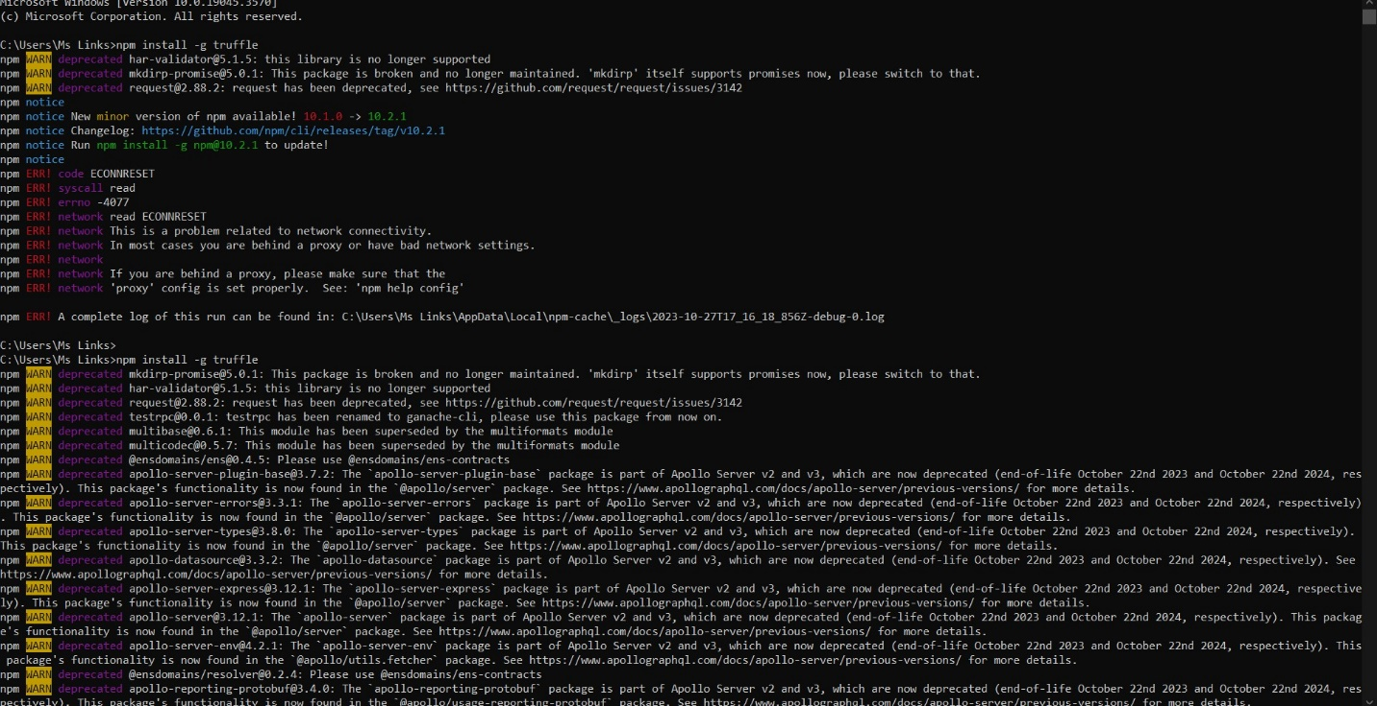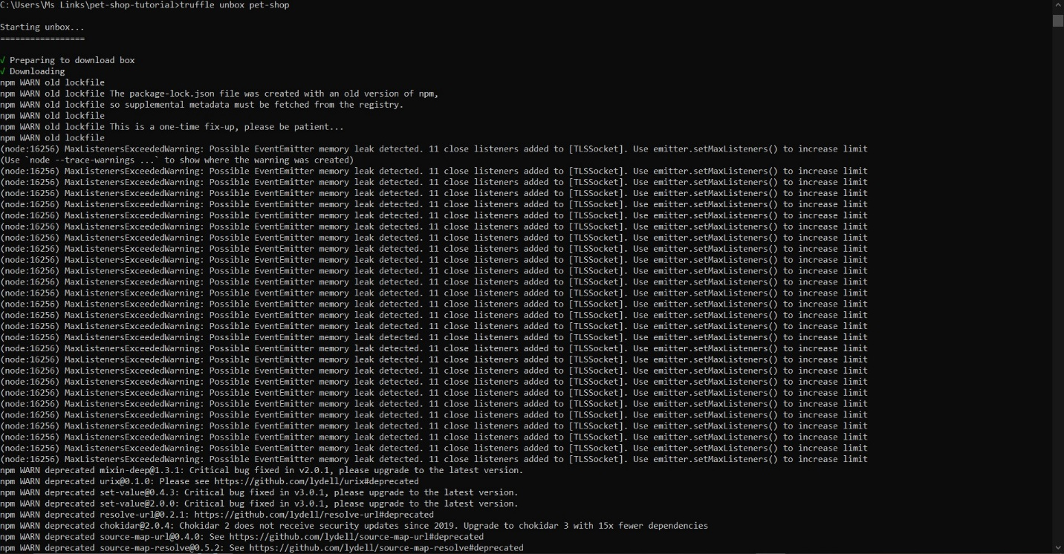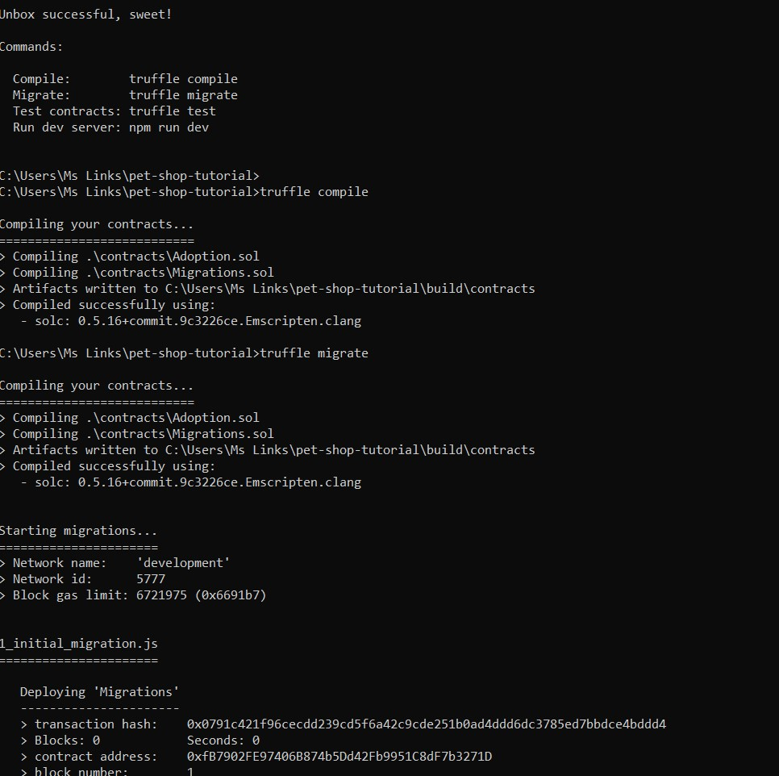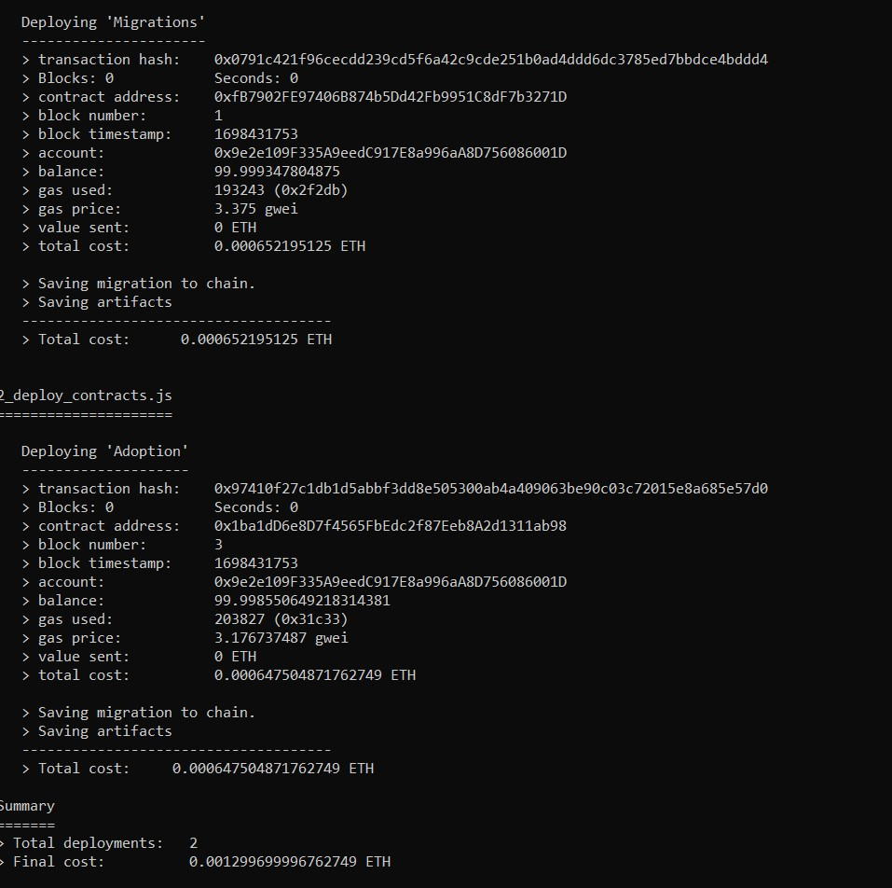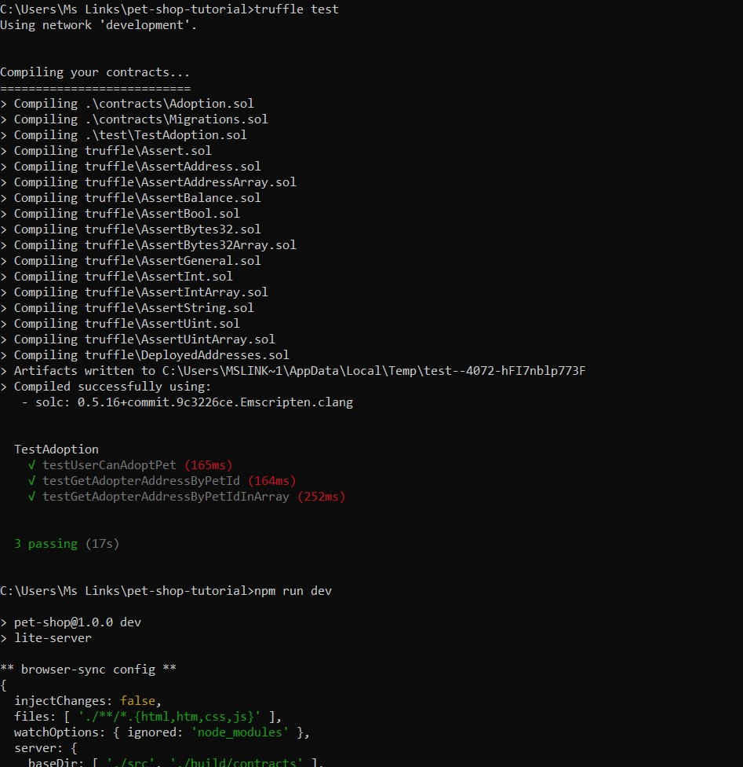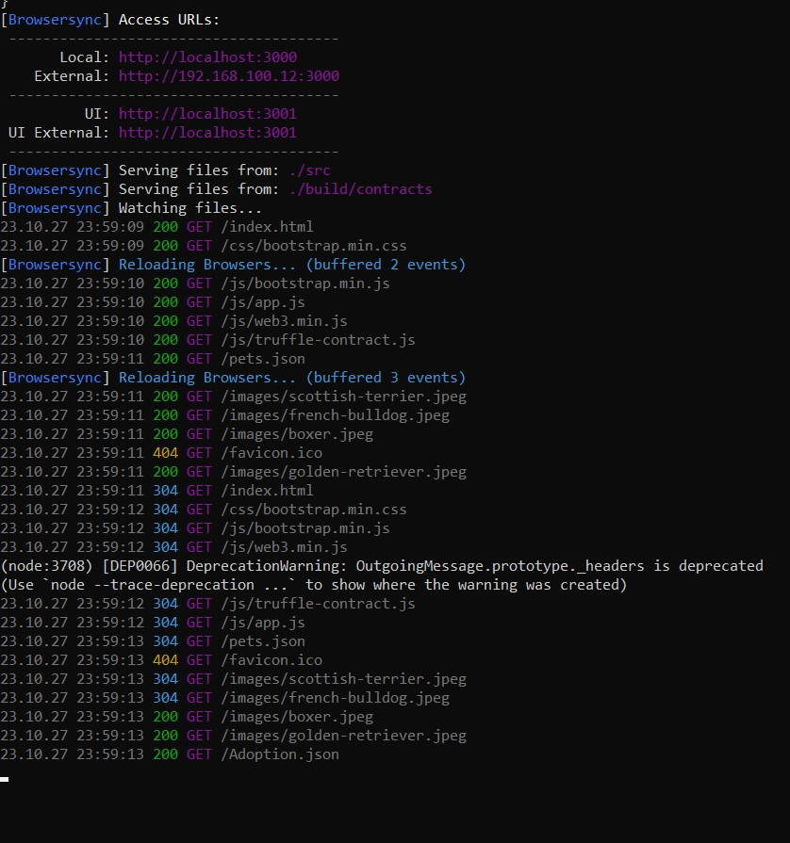

***Link to the Video recorded in Drive***

https://drive.google.com/drive/folders/1qg4BS9DvT9htM-kosp7bgvYkzZb_cpVl?usp=drive_link